1. Open the Windows Menu and select “Devices and Printers”  
   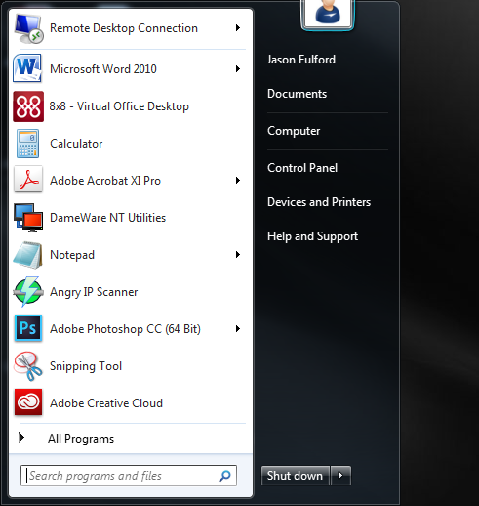
2. In the Devices and Printers window, right click on the printer you want as the Default and select “Set as Default” from the menu.